Deep Learning Project Report
Project Title: Speech Emotion Recognition using RNN + CNN
Course Title: Deep Learning
Student Name | Student Section | Student ID | Score
Zeina Ahmed Amin |  | 221017888
Malak Maher Mohamed |  | 221027544
Rola Khaled |  | 221017871

Section 1 — Problem Domain
  - Overview of the Problem
Speech Emotion Recognition (SER) is the task of automatically identifying the emotional state of a speaker from speech signals. Human emotions such as happiness, sadness, anger, calmness, and fear are implicitly conveyed through variations in acoustic properties, including pitch, energy, spectral distribution, and temporal dynamics. The objective of an SER system is to analyze these acoustic cues and map them to discrete emotional categories using signal processing and machine learning techniques.
Early SER systems relied heavily on handcrafted acoustic features (e.g., MFCCs, pitch statistics) combined with classical machine learning classifiers such as Support Vector Machines or Hidden Markov Models. While effective to a degree, these approaches were limited in their ability to model complex temporal dependencies and subtle emotional variations.
Recent advances in deep learning have significantly improved SER performance by enabling neural networks to learn discriminative representations directly from time–frequency audio features. Convolutional Neural Networks (CNNs) excel at capturing local spectral patterns, while recurrent architectures such as Long Short-Term Memory (LSTM) networks model temporal evolution. Hybrid CNN–LSTM architectures have therefore become a dominant approach in modern SER research.

  - Importance of the Problem
Accurate speech emotion recognition has significant applications across multiple domains:
- Human–Computer Interaction (HCI): Emotion-aware systems improve user experience in virtual assistants and conversational agents.
- Healthcare: SER can support mental health monitoring, stress detection, and early diagnosis of emotional disorders.
- Call Centers & Customer Analytics: Emotion analysis helps assess customer satisfaction and agent performance.
- Education & E-Learning: Adaptive systems can respond to learner frustration or engagement levels.
Despite these applications, SER remains challenging due to speaker variability, subtle emotional cues, and limited labeled datasets.

  - Dataset Description
This project uses the Ryerson Audio-Visual Database of Emotional Speech and Song (RAVDESS), a widely adopted benchmark dataset for emotion recognition research.
Key characteristics of the dataset include:
- Actors: 24 professional speakers (12 male, 12 female)
- Language: English
- Emotions: 8 discrete classes
(neutral, calm, happy, sad, angry, fearful, disgust, surprised)
- Modality: Speech audio (song data excluded)
- Sampling Rate: 44.1 kHz (resampled to 16 kHz during preprocessing)
- Recording Conditions: Clean, studio-quality recordings
RAVDESS provides balanced emotion classes and standardized recording conditions, making it suitable for controlled SER experiments while still presenting realistic modeling challenges.

  - Related Work Summary
Prior research in Speech Emotion Recognition can be broadly categorized into three approaches:
- Traditional Feature-Based Methods:
Early studies employed MFCCs, prosodic features, and statistical descriptors with classical classifiers. These approaches were computationally efficient but limited in expressive power.
- Deep Learning with Time–Frequency Representations:
CNN-based models trained on spectrograms or log-mel representations demonstrated significant improvements by learning spatial patterns related to emotional expression. Recurrent layers (LSTM, BiLSTM) further improved results by modeling temporal dependencies.
- Self-Supervised and Transformer-Based Models:
Recent works leverage pretrained models such as wav2vec 2.0 and HuBERT, achieving state-of-the-art accuracy. However, these models are computationally expensive and less interpretable, making them less suitable for small datasets and educational projects.
Most studies report that hybrid CNN–LSTM architectures using log-mel spectrograms achieve strong performance on datasets such as RAVDESS, typically outperforming classical baselines.

1.5 Research Gap / Motivation
Most baseline SER implementations:
- Ignore global normalization consistency
- Apply augmentation incorrectly to validation/test data
- Suffer from label imbalance or encoding errors
- Collapse to predicting one dominant emotion
This project addresses these issues by:
- Enforcing strict preprocessing consistency
- Separating dataset creation from training augmentation
- Using CNN + BiLSTM to model both spectral and temporal cues
- Building a reproducible end-to-end pipeline from audio to GUI prediction

Section 2 — Project Summary
2.1 System Architecture
The proposed system follows a modular pipeline:
Audio Input → Preprocessing → Feature Extraction → CNN Feature Encoder → BiLSTM Temporal Modeling → Softmax Classification → Emotion Prediction
The architecture separates data preprocessing, model training, evaluation, and deployment into well-defined components, ensuring clarity and reproducibility.
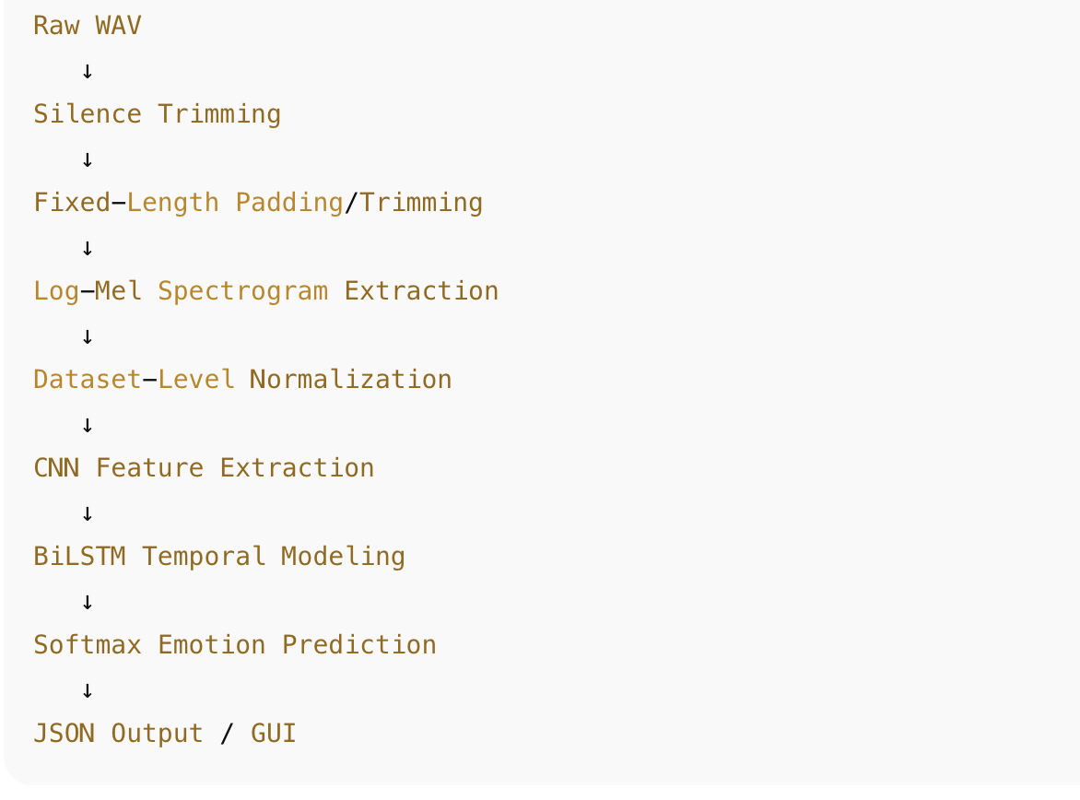
2.2 Tools & Libraries Used
- Python 3.10
- Librosa – audio loading and feature extraction
- NumPy – numerical operations
- TensorFlow / Keras – model implementation and training
- Scikit-learn – dataset splitting and evaluation metrics
- Matplotlib & Seaborn – visualisation
- JSON – model statistics and inference output

2.3 Data Preprocessing
- Load audio
- Trim silence
- Pad or trim to fixed duration (2 seconds)
- Extract log-mel spectrogram (128 × 128)
- Dataset-level normalization:
- X = (X − mean) / std
- Save:
  - X.npy
  - y.npy
  - mean_std.json
Important:
No augmentation is applied during dataset creation.

2.4 Model Architecture
CNN + BiLSTM Hybrid Model
- Input: (128, 128, 1) log-mel spectrogram
- CNN blocks:
  - Extract local time–frequency emotion patterns
  - Batch normalization + dropout for stability
- Reshape layer:
Converts spatial CNN output into temporal sequences
- BiLSTM:
Captures forward and backward emotional dynamics
- Dense head:
Maps learned features to emotion probabilities
This design allows:
- CNN → spectral representation learning
- BiLSTM → temporal emotion modeling

2.5 Training Pipeline
- Load X.npy, y.npy
- Stratified train/validation/test split
- One-hot encoding of labels
- Training-only augmentation:
- SpecAugment (time & frequency masking)
- Noise injection
- Compile model:
- Adam optimizer
- Categorical cross-entropy
- Train with callbacks:
- ReduceLROnPlateau
- Early stopping
- Save:
- best_model.h5
- final_model.h5
- history.json

2.6 Deployment Approach
- Model and normalization statistics loaded at runtime
- Incoming audio processed using same preprocessing
- Model outputs probabilities
- Results returned as structured JSON
- Integrated into GUI for real-time inference

Section 3 — Results & Visualisations
3.1 Training Curves
- Smooth convergence
- No overfitting
- Validation closely follows training
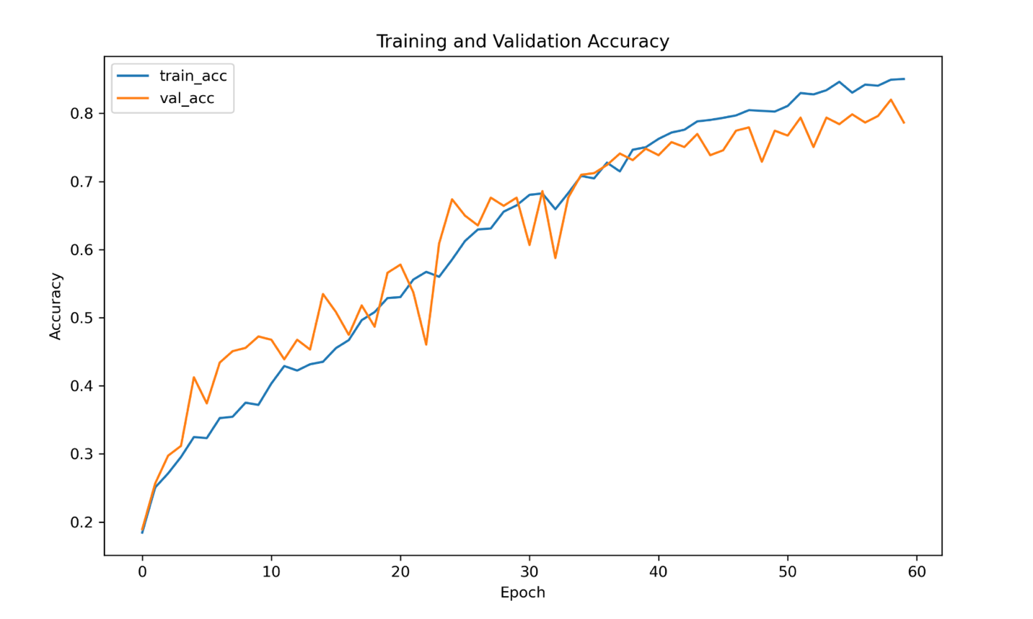
3.2 Confusion Matrix
- Strong diagonal dominance
- Minor confusion between similar emotions (e.g., calm vs neutral)
